Highly Available 3-Tier Web Application on AWS

1. Objective
The objective of this project is to design and deploy a highly available, scalable, and fault-tolerant 3-tier web application on AWS. The system should handle traffic spikes efficiently and provide secure access over HTTPS.

2. Business Scenario
A fast-growing e-commerce startup requires a web application infrastructure that:
- Handles high traffic during sales events (e.g., Black Friday)
- Ensures high availability across multiple Availability Zones
- Supports auto scaling based on demand
- Provides secure HTTPS access
- Maintains session persistence for shopping cart functionality

3. AWS Services Used
- Amazon EC2
- Application Load Balancer
- Auto Scaling Groups
- Amazon EBS
- Amazon S3
- AWS Certificate Manager
- AWS KMS
- Amazon VPC

4. Architecture Overview
Internet
↓
Application Load Balancer (HTTPS:443)
↓
Target Group
├── AZ-1a: EC2 Instance (Auto Scaling Group)
├── AZ-1b: EC2 Instance (Auto Scaling Group)
↓
EBS gp3 (Encrypted Storage)
↓
S3 Bucket (Static Assets)
↓
Bastion Host (Public Subnet for SSH Access)

5. Infrastructure Setup

5.1 Create VPC and Subnets
- Create a VPC with CIDR (e.g., 10.0.0.0/16)
- Create:
  - 2 Public Subnets (for ALB & Bastion Host)
  - 2 Private Subnets (for EC2 App Servers)
- Configure:
  - Internet Gateway (for public subnets)
  - NAT Gateway (for private subnet internet access)

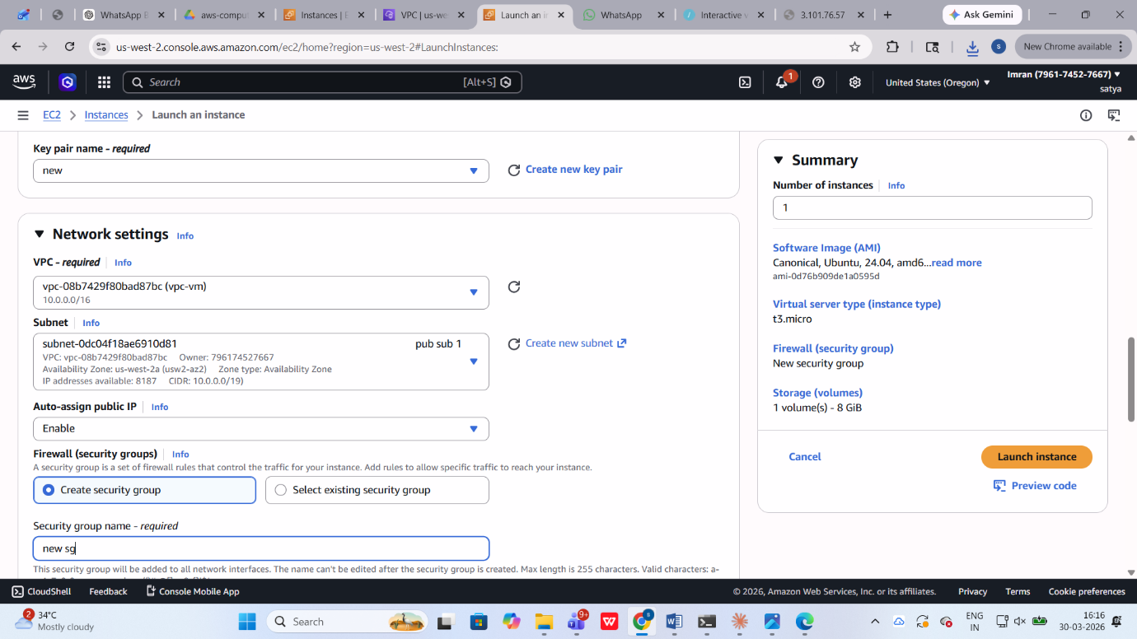

5.2 Launch EC2 Instances (Golden AMI)
- Create a Golden AMI with:
  - Apache/Nginx installed
  - Application code pre-configured
- Use User Data Script to start services automatically
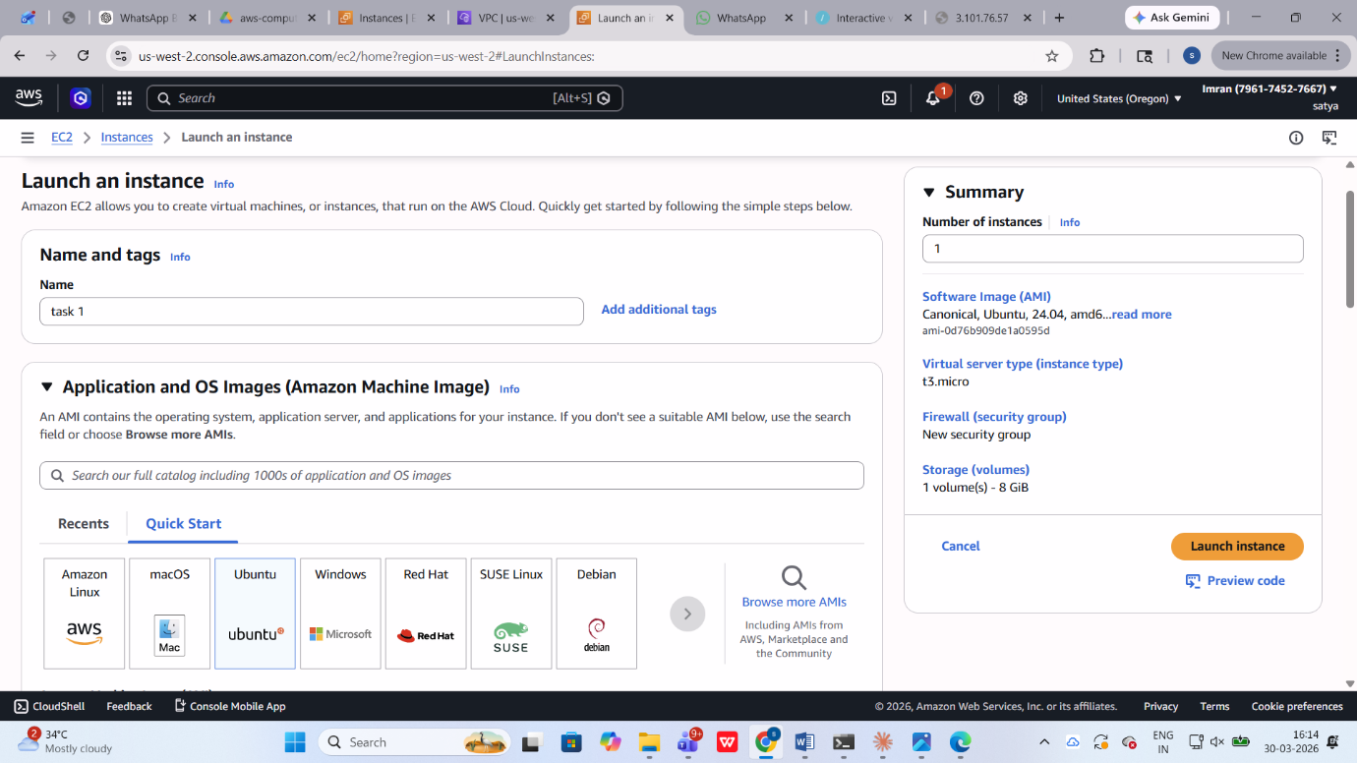

5.3 Configure Storage (EBS)
- Attach 20 GB gp3 EBS volume to each EC2 instance
- Enable encryption using AWS KMS
- Mount volume to application directory

5.4 Setup S3 Bucket
- Create an S3 bucket for static assets (images, CSS, JS)
- Enable:
  - Versioning (optional)
  - Public or controlled access
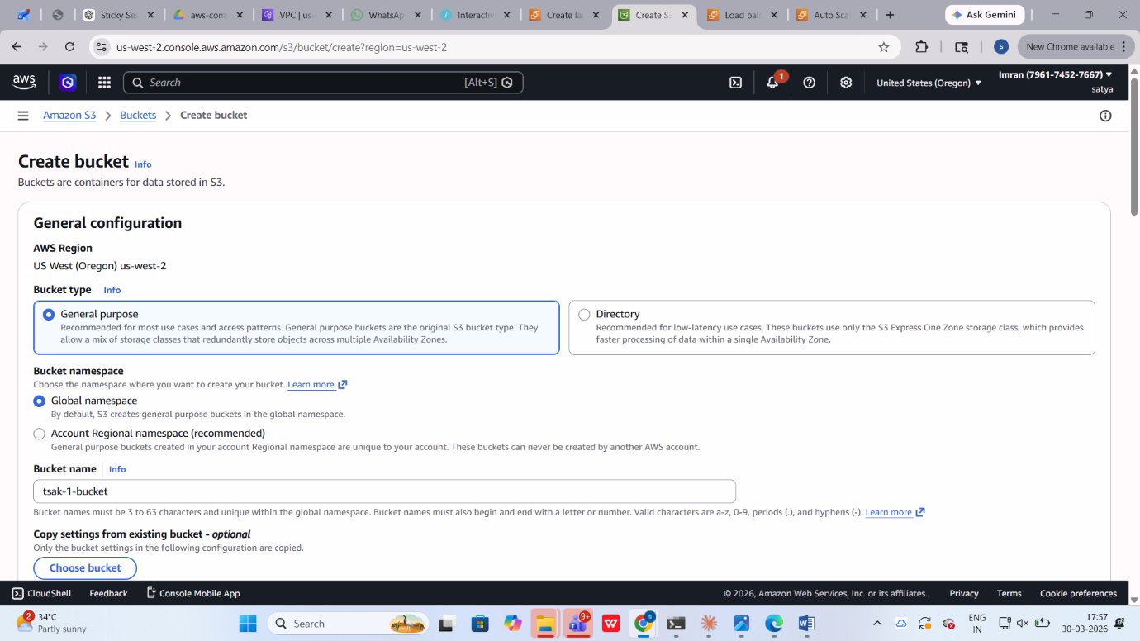

5.5 Bastion Host Setup
- Launch Bastion Host in public subnet
- Assign Elastic IP
- Allow SSH access (port 22)

6. Load Balancer Configuration

6.1 Create Application Load Balancer
- Scheme: Internet-facing
- Listener: HTTPS (Port 443)
- Attach ACM SSL Certificate
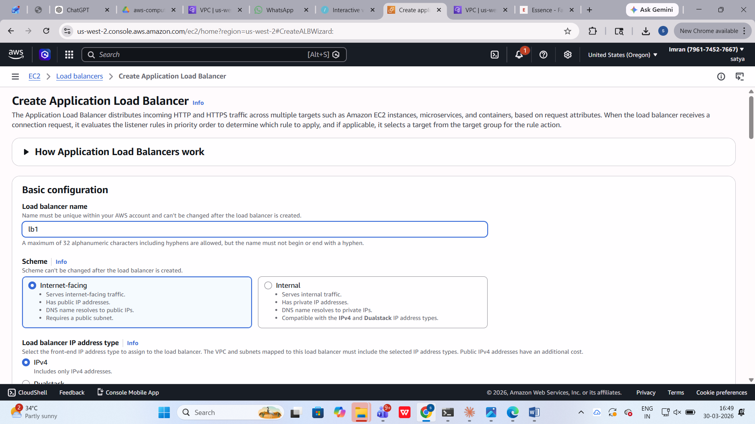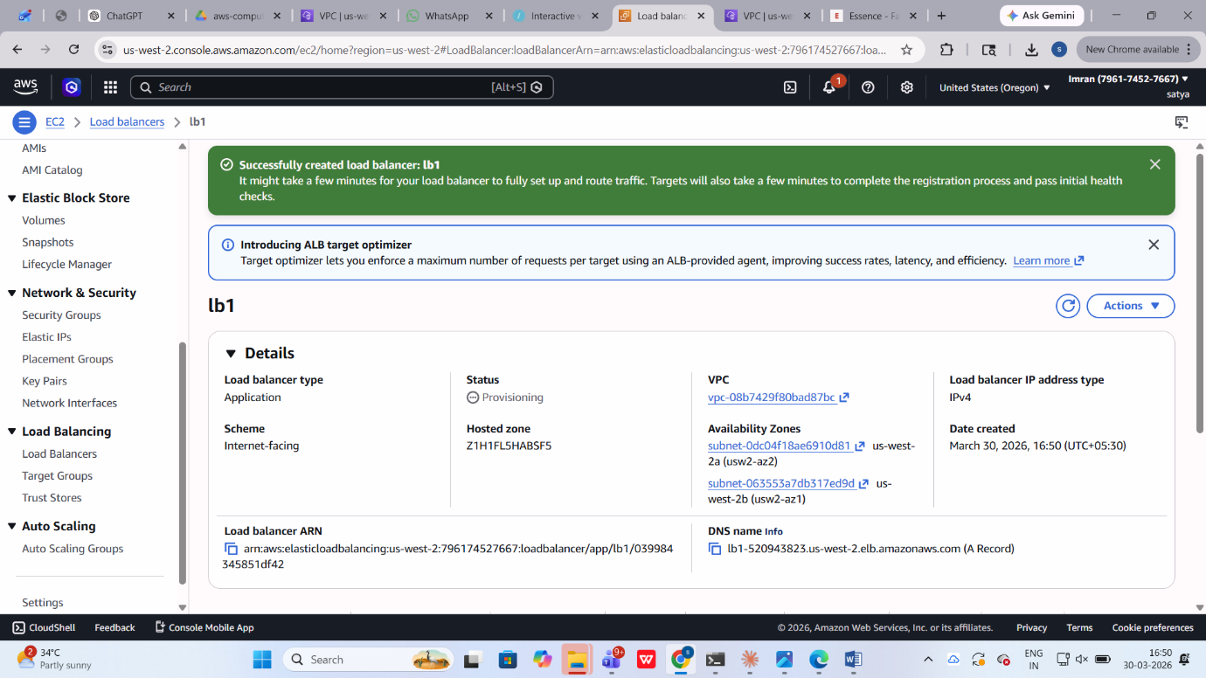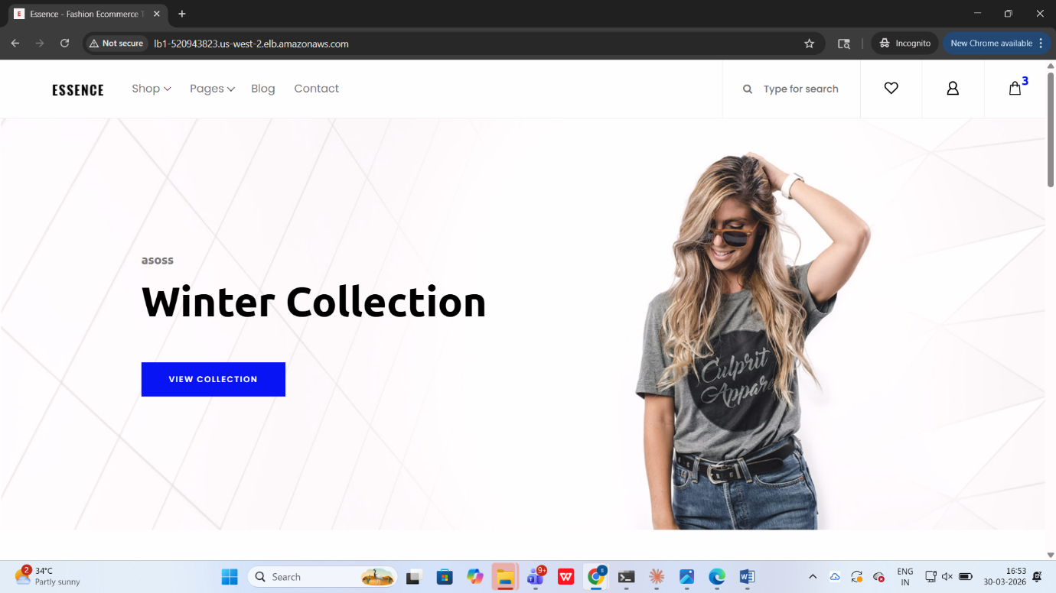

6.2 Configure Target Group
- Register EC2 instances
- Health Check:
  - Path: /
  - Protocol: HTTP
- 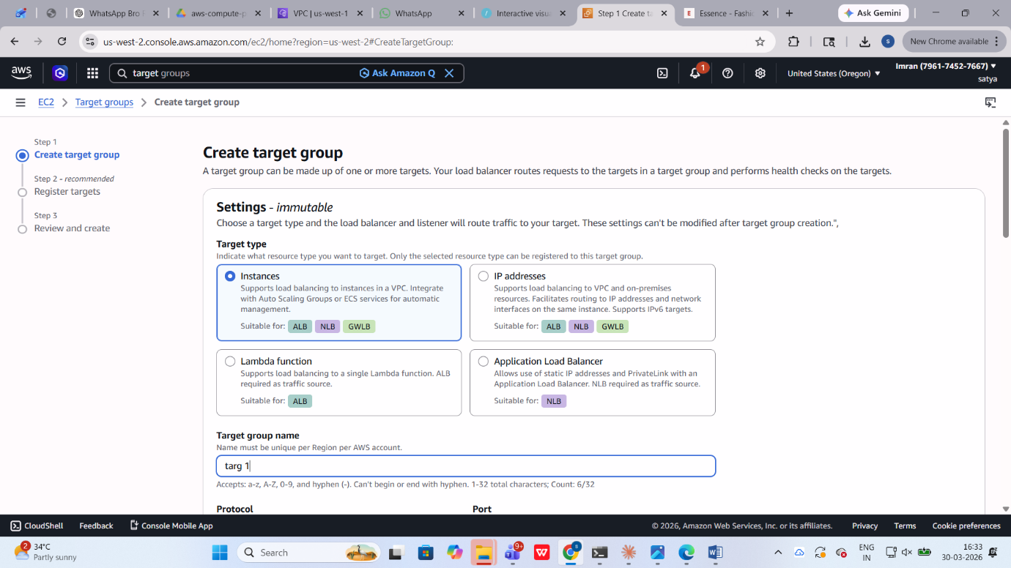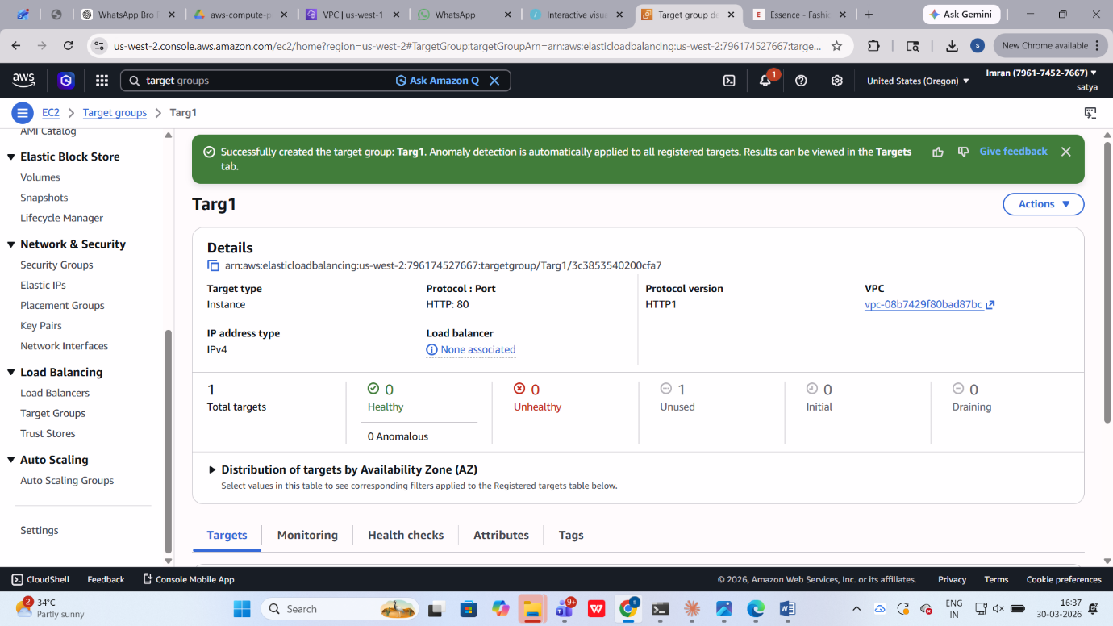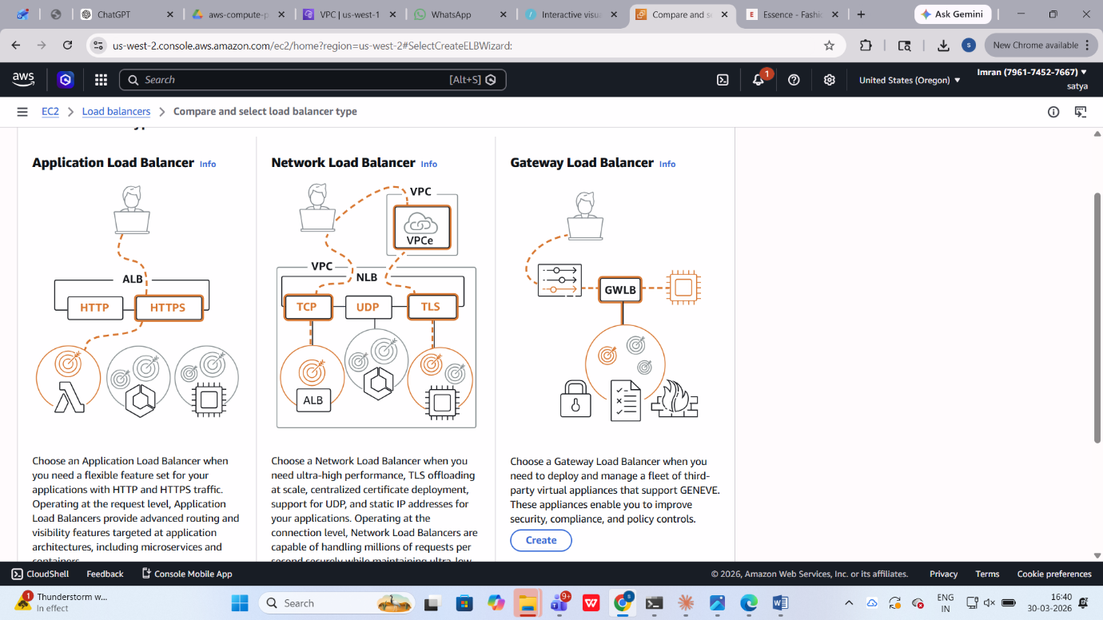

6.3 Enable Cross-Zone Load Balancing
- Ensure traffic is evenly distributed across AZs
Screenshot:
(Insert Cross-zone LB setting screenshot here)
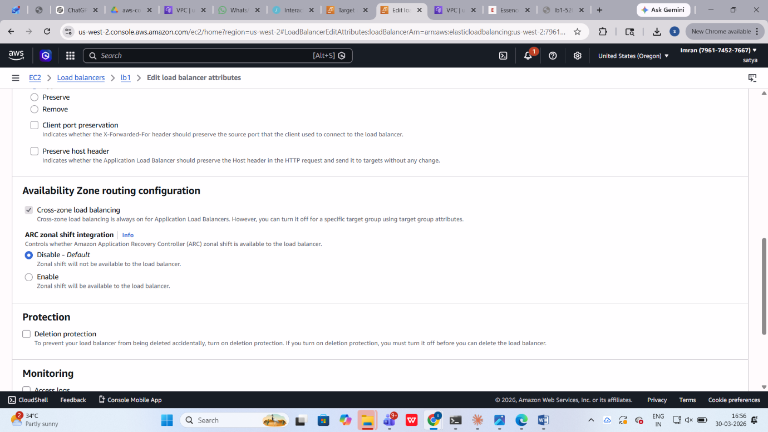

6.4 Configure Sticky Sessions
- Enable session stickiness
- Duration: 1 hour
- Used for shopping cart persistence
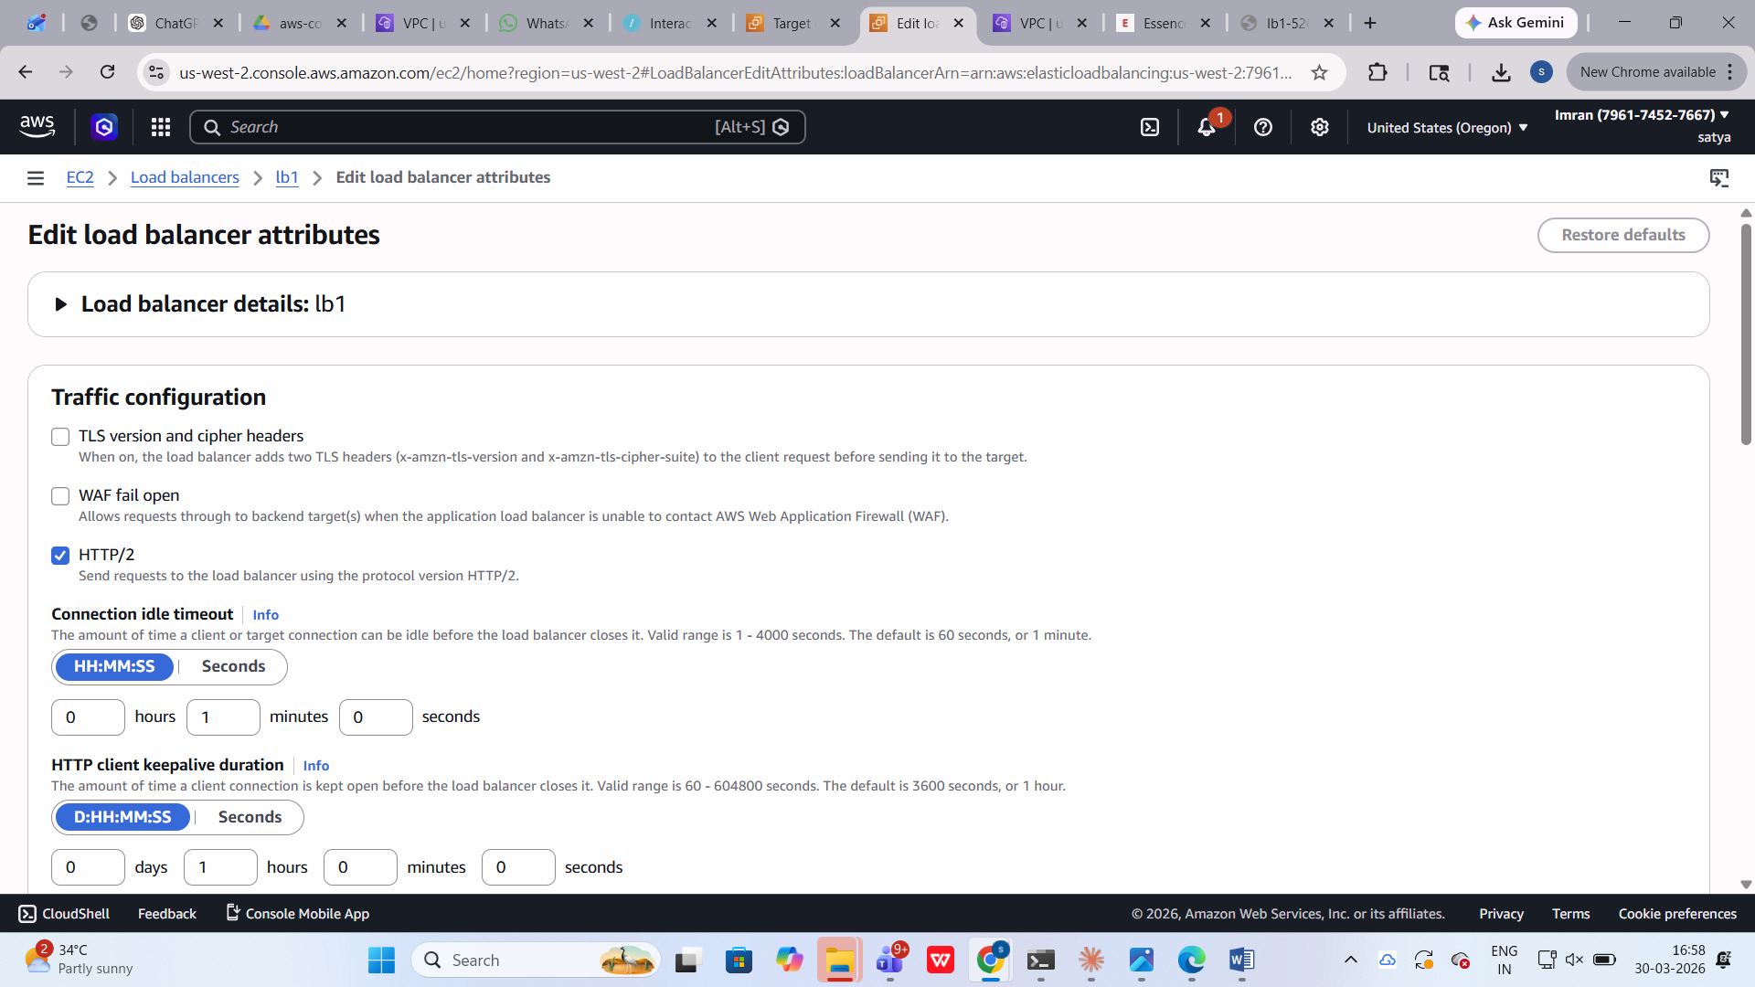

7. Auto Scaling Configuration
- Create Launch Template using Golden AMI
- Configure Auto Scaling Group:
  - Minimum: 2 instances
  - Maximum: 4 instances
  - Desired: 2 instances
- Enable scaling policy based on CPU usage
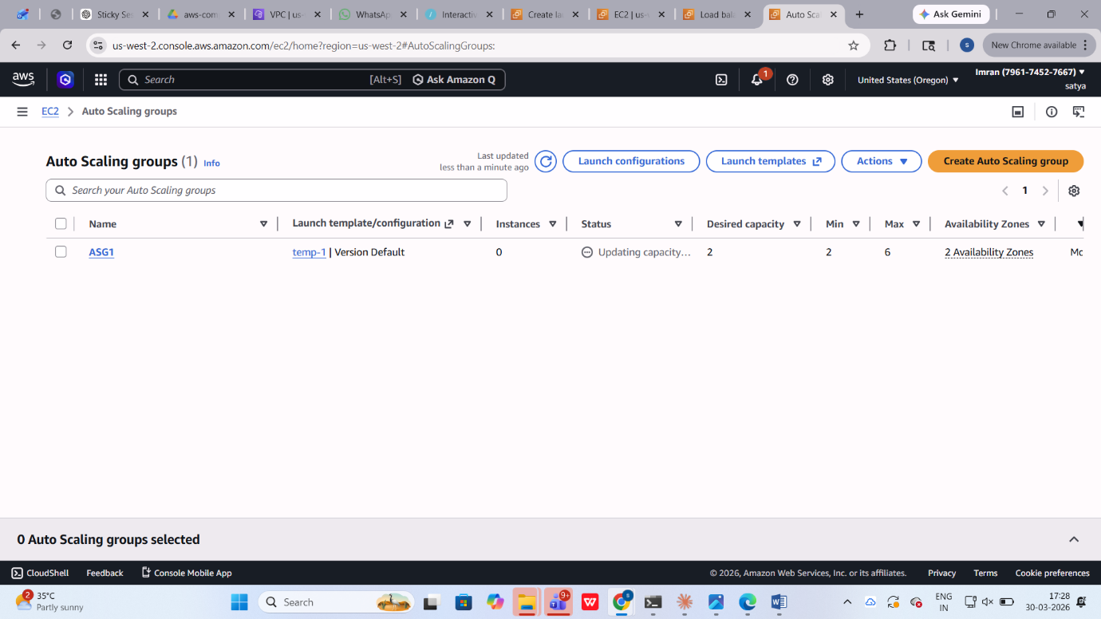

8. Security Configuration
- Security Groups:
  - ALB: Allow HTTPS (443)
  - EC2: Allow HTTP (80) from ALB only
  - Bastion: Allow SSH (22) from your IP
- Enable encryption:
  - EBS via KMS
  - HTTPS via ACM

9. Validation & Testing

9.1 Test Application Access
- Access application using ALB DNS over HTTPS



9.2 Test High Availability
- Stop one instance → Application should still work

9.3 Test Auto Scaling
- Simulate load → New instances should launch automatically

10. Key Concepts Covered
- EC2 Instance Types & AMI
- User Data Automation
- Application Load Balancer
- Cross-Zone Load Balancing
- Sticky Sessions
- Auto Scaling Groups
- Secure Architecture (HTTPS, KMS)

11. Conclusion
This project demonstrates how to build a production-ready, scalable, and highly available AWS architecture. The system ensures:
- Fault tolerance across Availability Zones
- Secure communication via HTTPS
- Dynamic scaling based on demand
- Persistent user sessions for better user experience

